NAME : NAVODITAA A.R.
ROLL NO.: 241901071

Exercise 8

BUILDING AN ANONYMOUS FTP SCANNER USING FTPLIB MODULE
INTRODUCTION:
Anonymous FTP servers allow logging in with the username anonymous (often using an email as password). A basic anonymous FTP scanner tries to connect to FTP servers (port 21) and attempts an anonymous login to check whether anonymous access is allowed.
AIM:
Create a small Python script that checks one or more hosts for FTP service and reports whether anonymous login is permitted.
ALGORITHM:
- For each target host: try a TCP connection to port 21 (quick reachability check).
- If reachable, open an ftplib.FTP connection and attempt login('anonymous', 'anonymous@').
- Record and print whether anonymous login succeeded, was refused, or connection failed.
- Repeat for all targets.
CODE:
import ftplib
def anonymousLogin(hostname):
try:
ftp = ftplib.FTP(hostname)
response = ftp.login('anonymous', 'anonymous')
print(response)
if "230 Anonymous access granted" in response:
print('\n[*] ' + str(hostname) +' FTP Anonymous Login Succeeded.')
print(ftp.getwelcome())
ftp.dir()
except Exception as e:
print(str(e))
print('\n[-] ' + str(hostname) +' FTP Anonymous Login Failed.')
hostname = 'ftp.be.debian.org'
anonymousLogin(hostname)

OUTPUT:
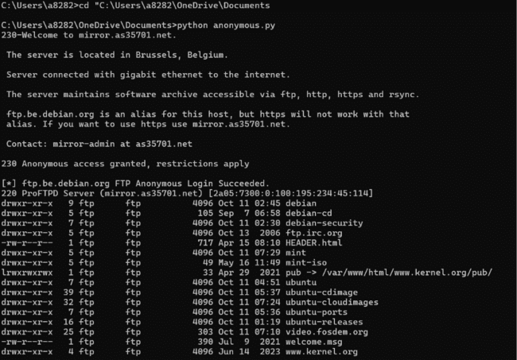

RESULT:
The anonymous FTP scanner successfully attempted connections to target hosts and tried to log in using the anonymous account.

